CloudX Associate: MS Azure Java Developer – Module 2 - Tasks

Subtask -1 : Signing in to CLI
- Logging in to az with my subscription:
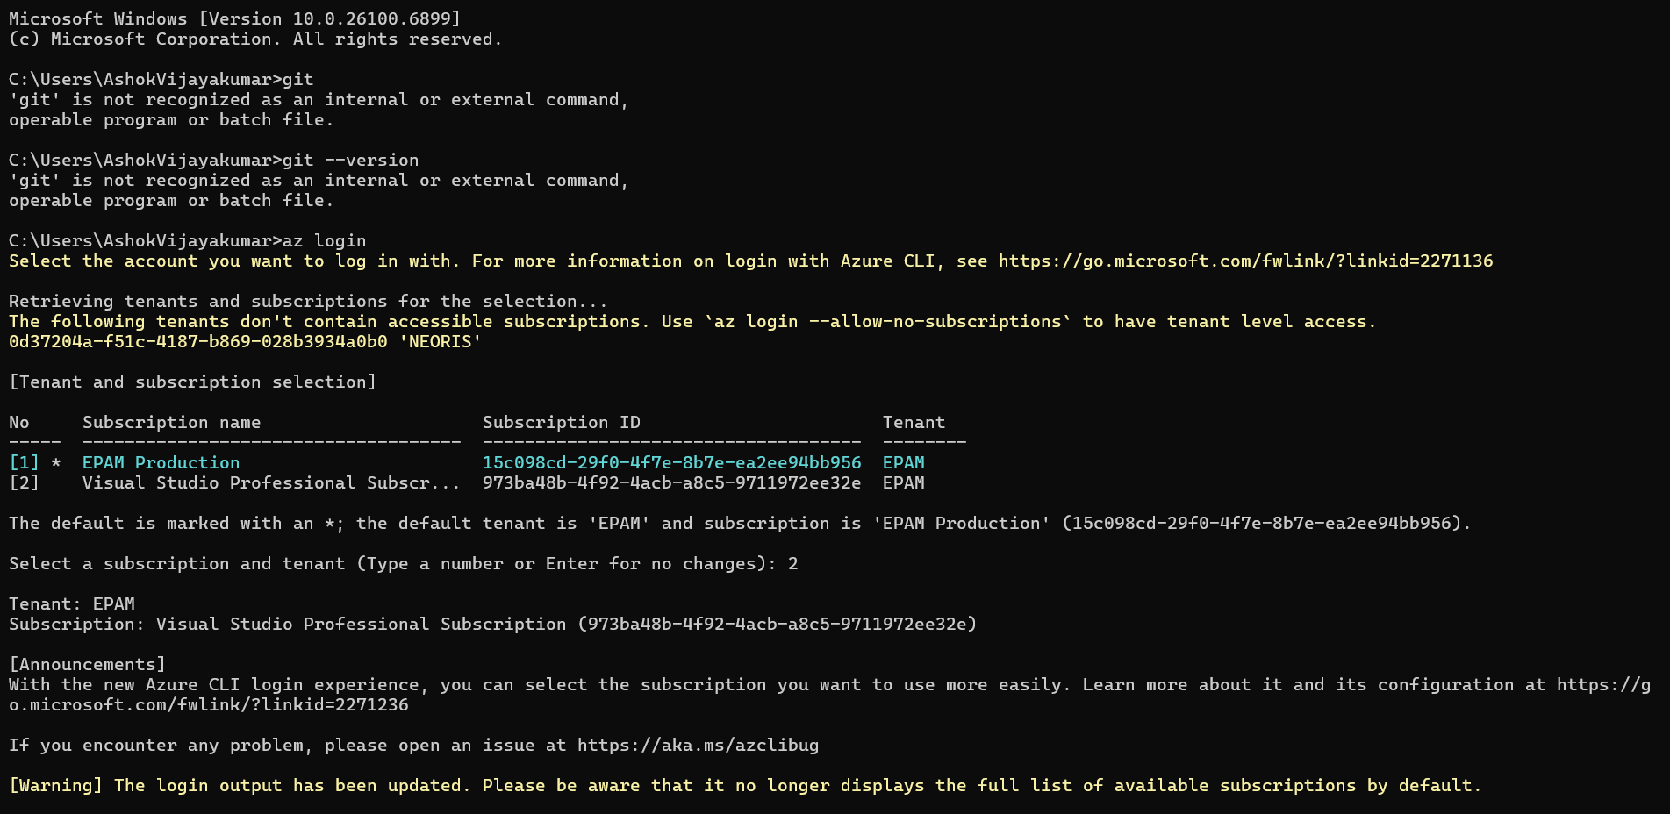

Subtask 2: Resource Groups
- Use the az group list command to list all available resource groups in your subscription
Output: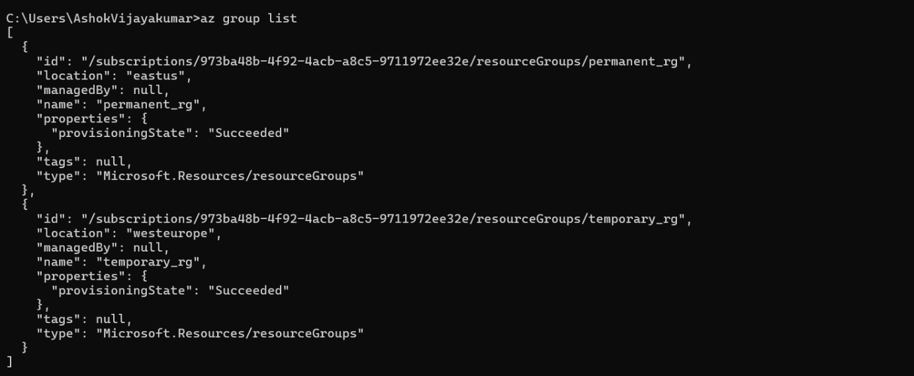

- Change the previous command to get a table.
Outuput: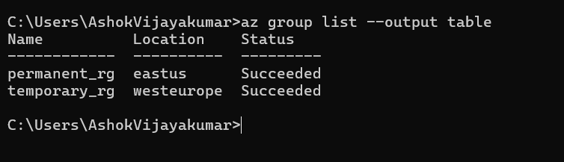

- Use the az group show command to output detailed information about the permanent resource group.
Output:
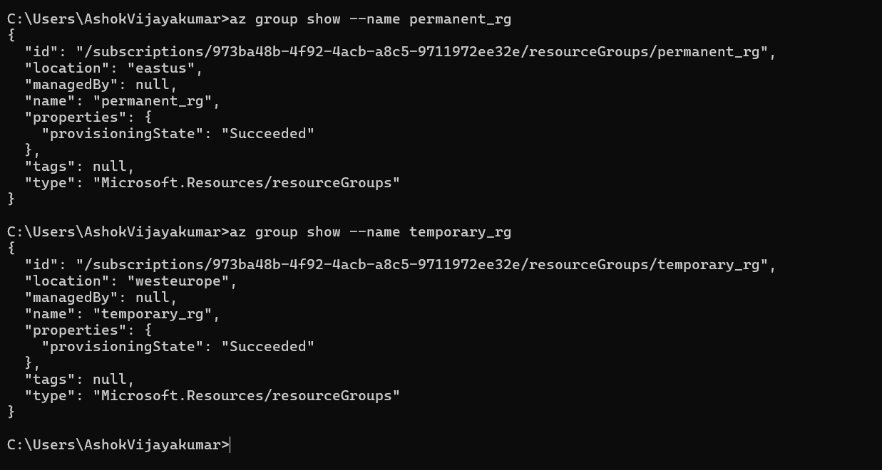
- Use the az group list command to list as a table and filter resource groups, using the variable in which you stored the location of the permanent resource group.
output: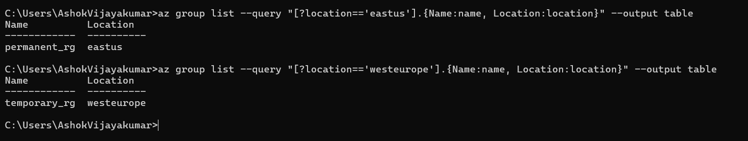

- Use the az group show command to save the permanent resource group ID to a variable and output it.
Output:
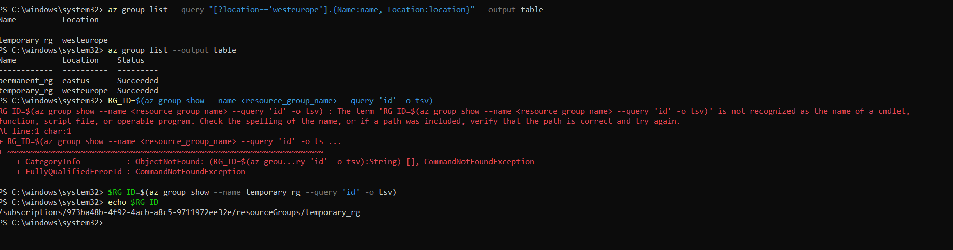
- Use the az group delete command along with the variable containing the name of the temporary resource group to delete it. Use a necessary option to do it without being prompted for additional confirmation. Also Check if the temporary resource group has been deleted. List all available resource groups in your subscription again as a table. Make sure the temporary resource group is no longer listed among the available resource groups. The permanent resource group should still be present.
Output:
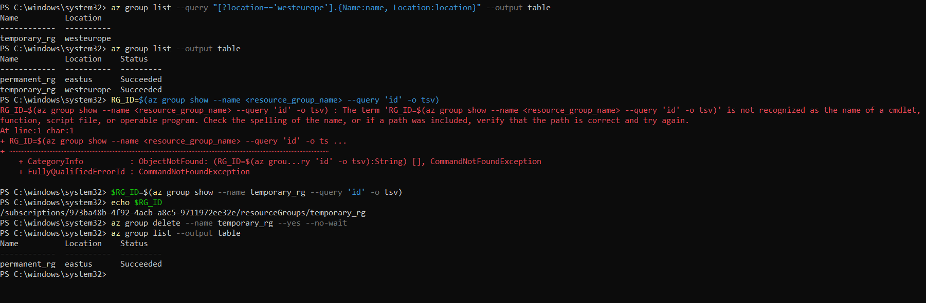

Subtask 3: Azure Container Registry (ACR)
- Set a variable for the Azure Container Registry name (use alphanumeric characters only).
- Create Azure Container Registry
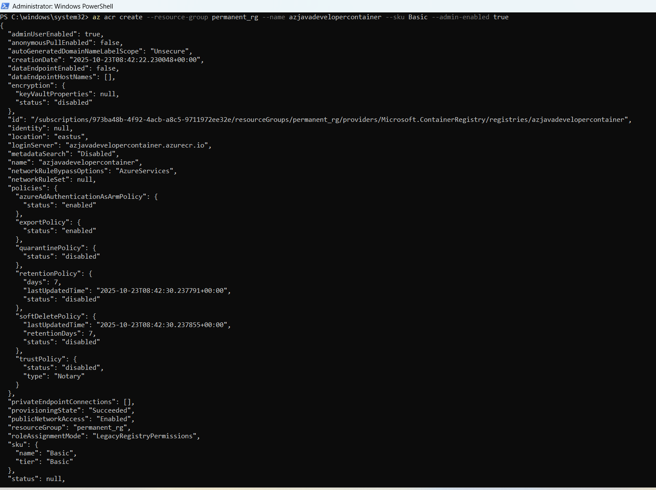
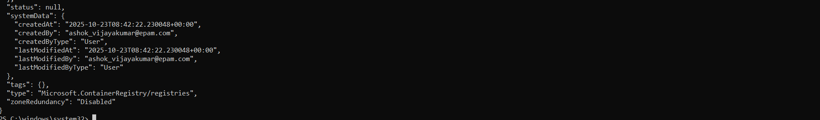
- Use the az resource list command to list the resources in the permanent resource group. Use the proper option to get a table
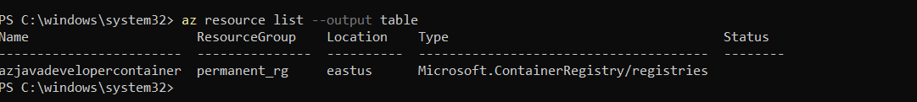

- Use the az acr credential show command to retrieve the username and password. Use --output yaml option. This will display the credentials in a YAML format. Please make sure to save them for the next subtask.
Environment Variables:
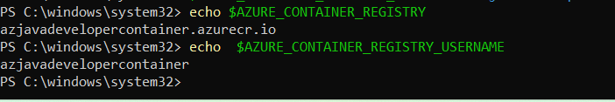

Subtask 4: Creating a GitHub repository and setting a secret
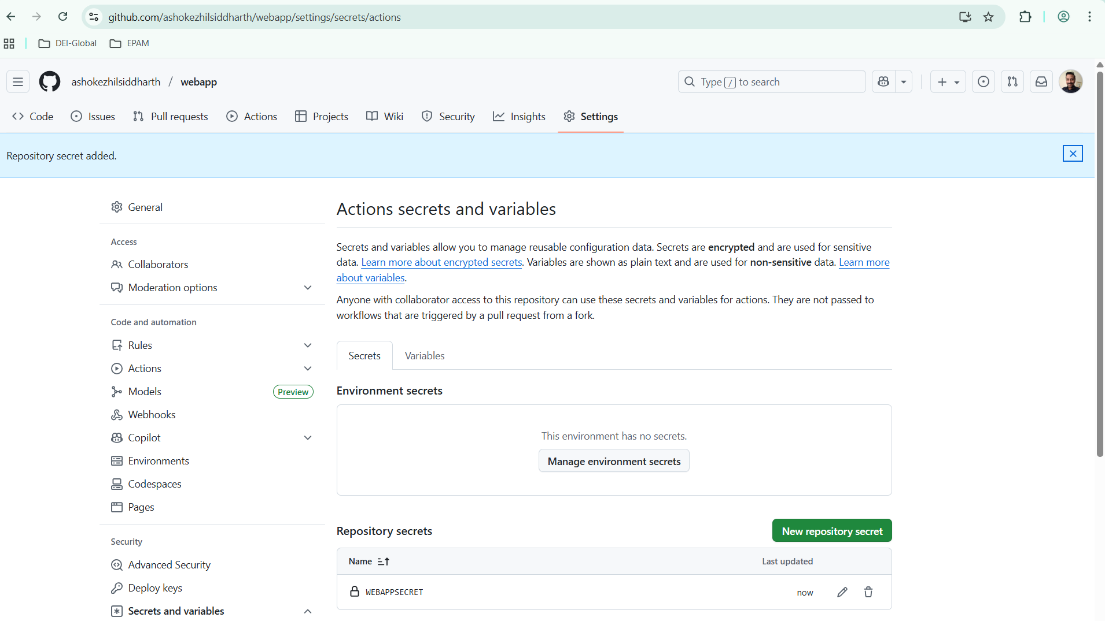

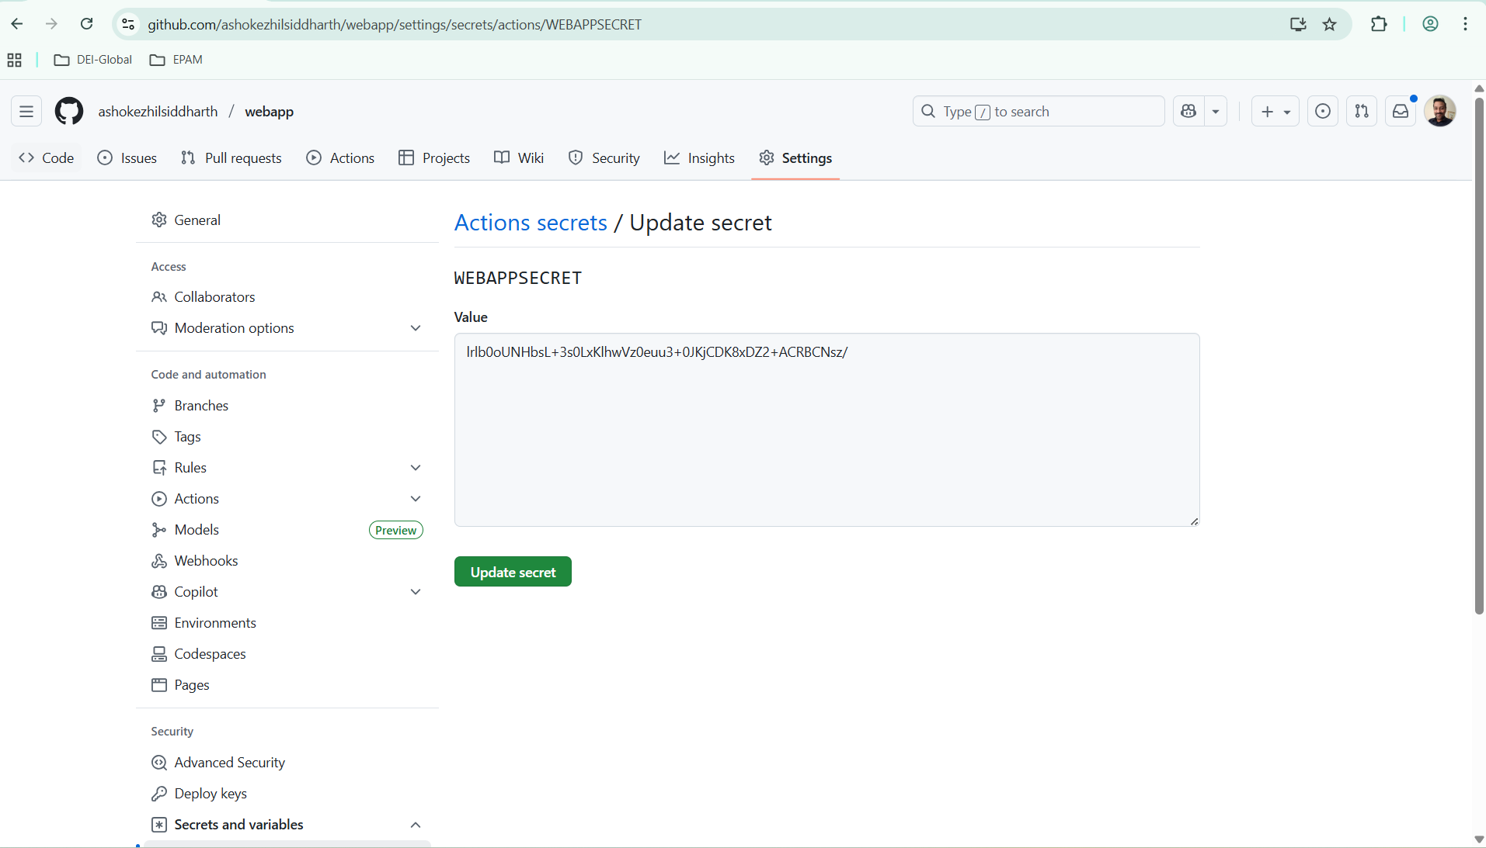

Subtask 5: CI/CD to Azure Container Registry with GitHub Actions

Environment variable updated with azure container registry and username as shown below,
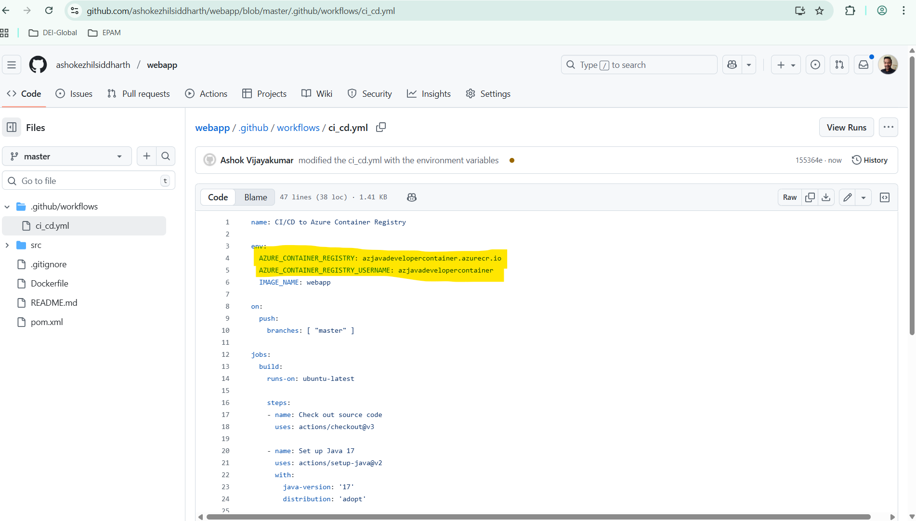

Use the az acr repository list command to list the repositories in "yourcontainerregistry". Use the proper option to get a table.
output:
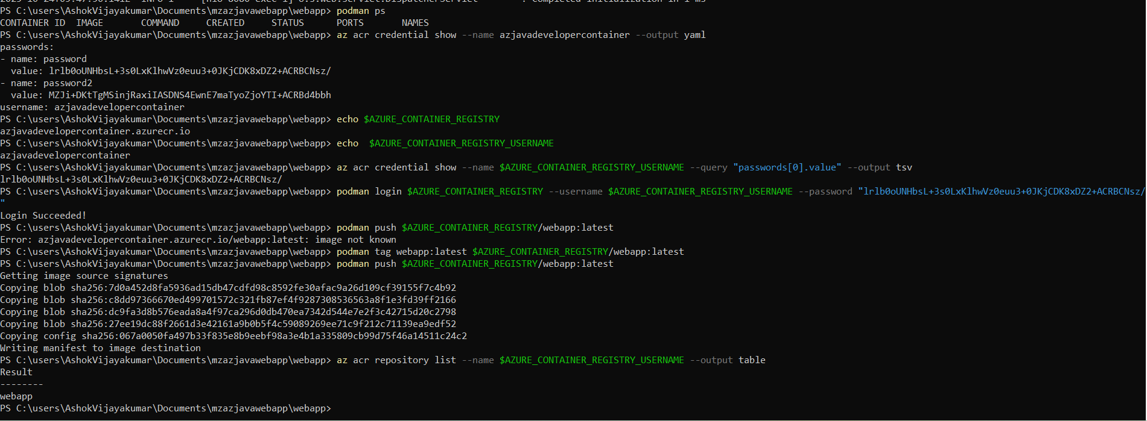

Use the az acr repository show-tags command to display the Docker image tags for the "webapp" repository.
Output:
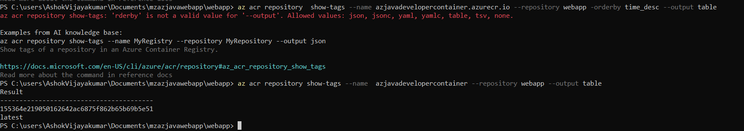

Use the az acr repository show-tags command with --orderby time_desc option to find the oldest image.
Sample output:
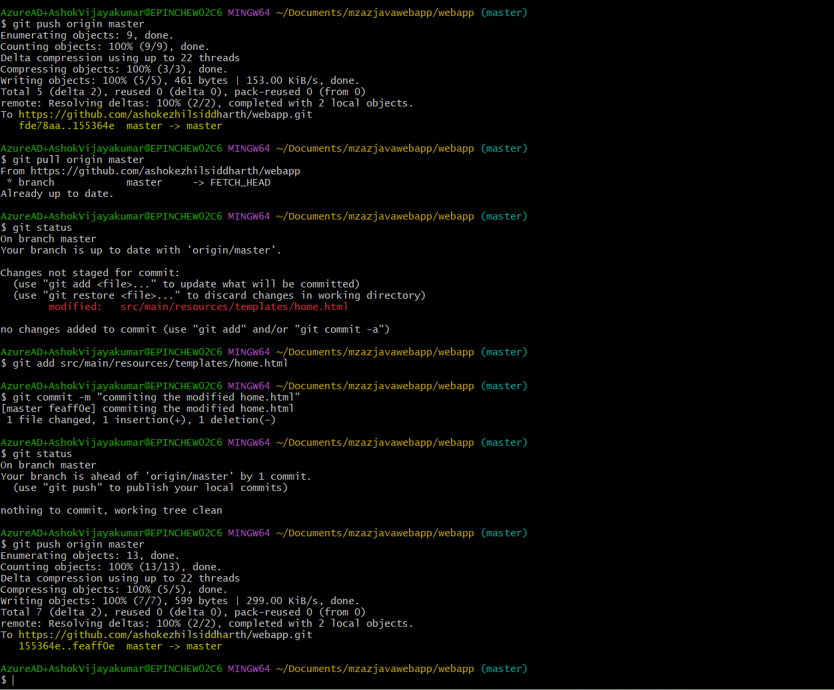

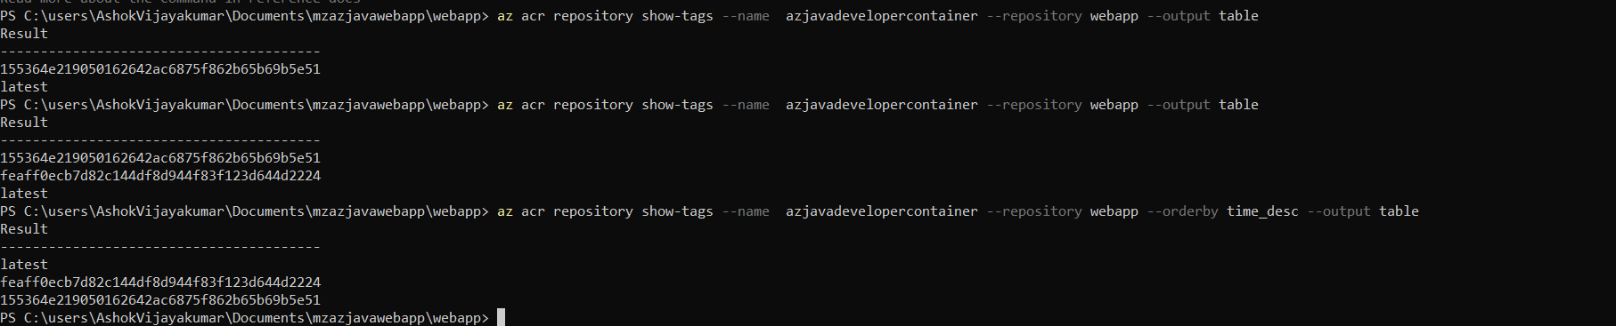

Use the az acr repository delete command with the full SHA of the oldest image (in our case, 155364e219050162642ac6875f862b65b69b5e51) and the -y option to delete it. The -y option is used to automatically confirm the deletion without waiting for interactive user input.
Output:
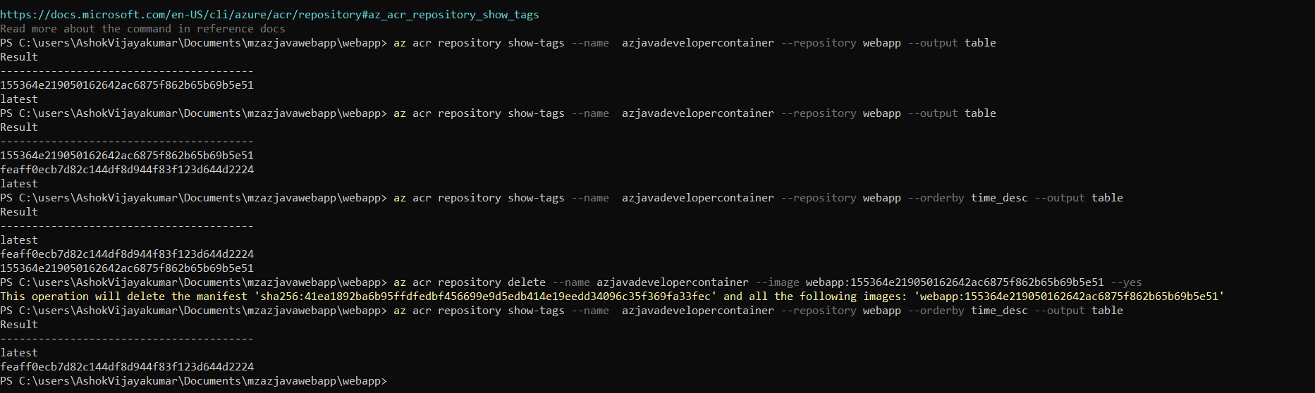

Subtask 6: Creating a Web App in Azure App Services

Use the az group create command to create a temporary resource group in East US location.
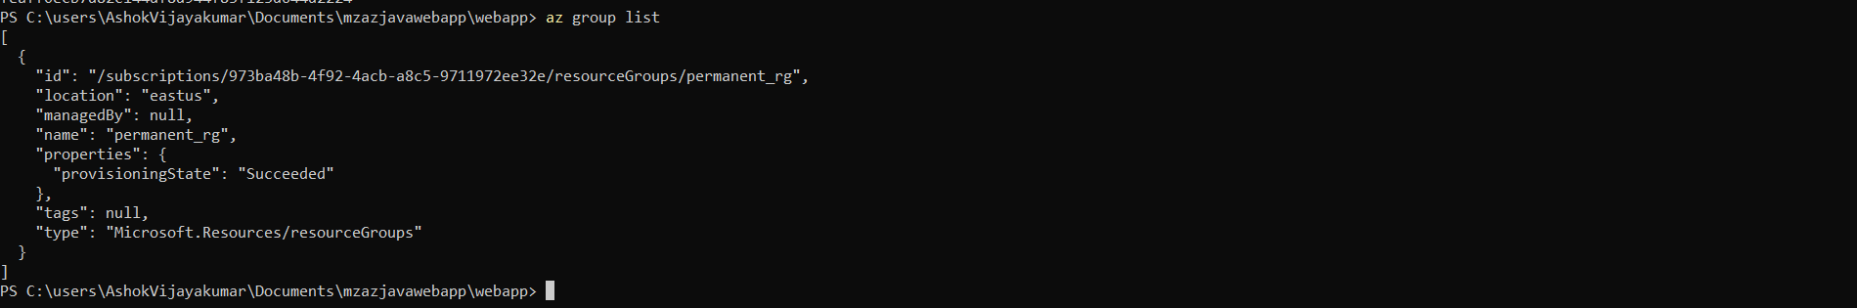

Use the az appservice plan create command to create an App Service plan in East US location.
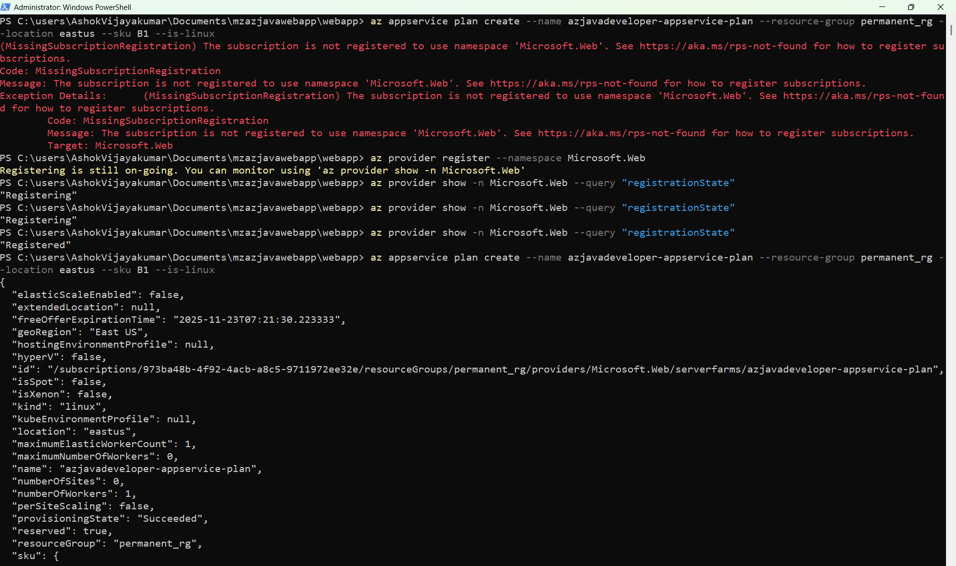
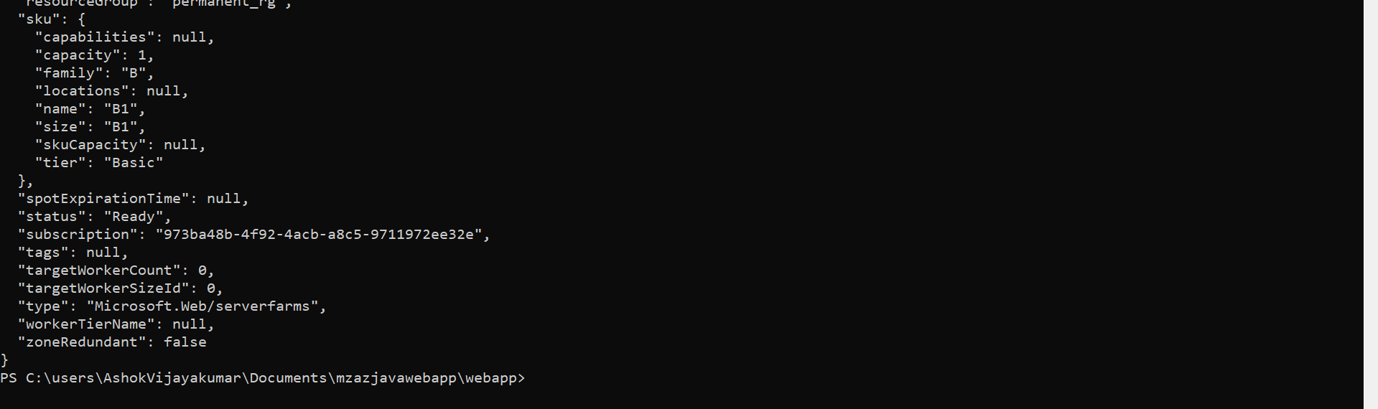

Use the az webapp create command to create the web app and deploy the container image.
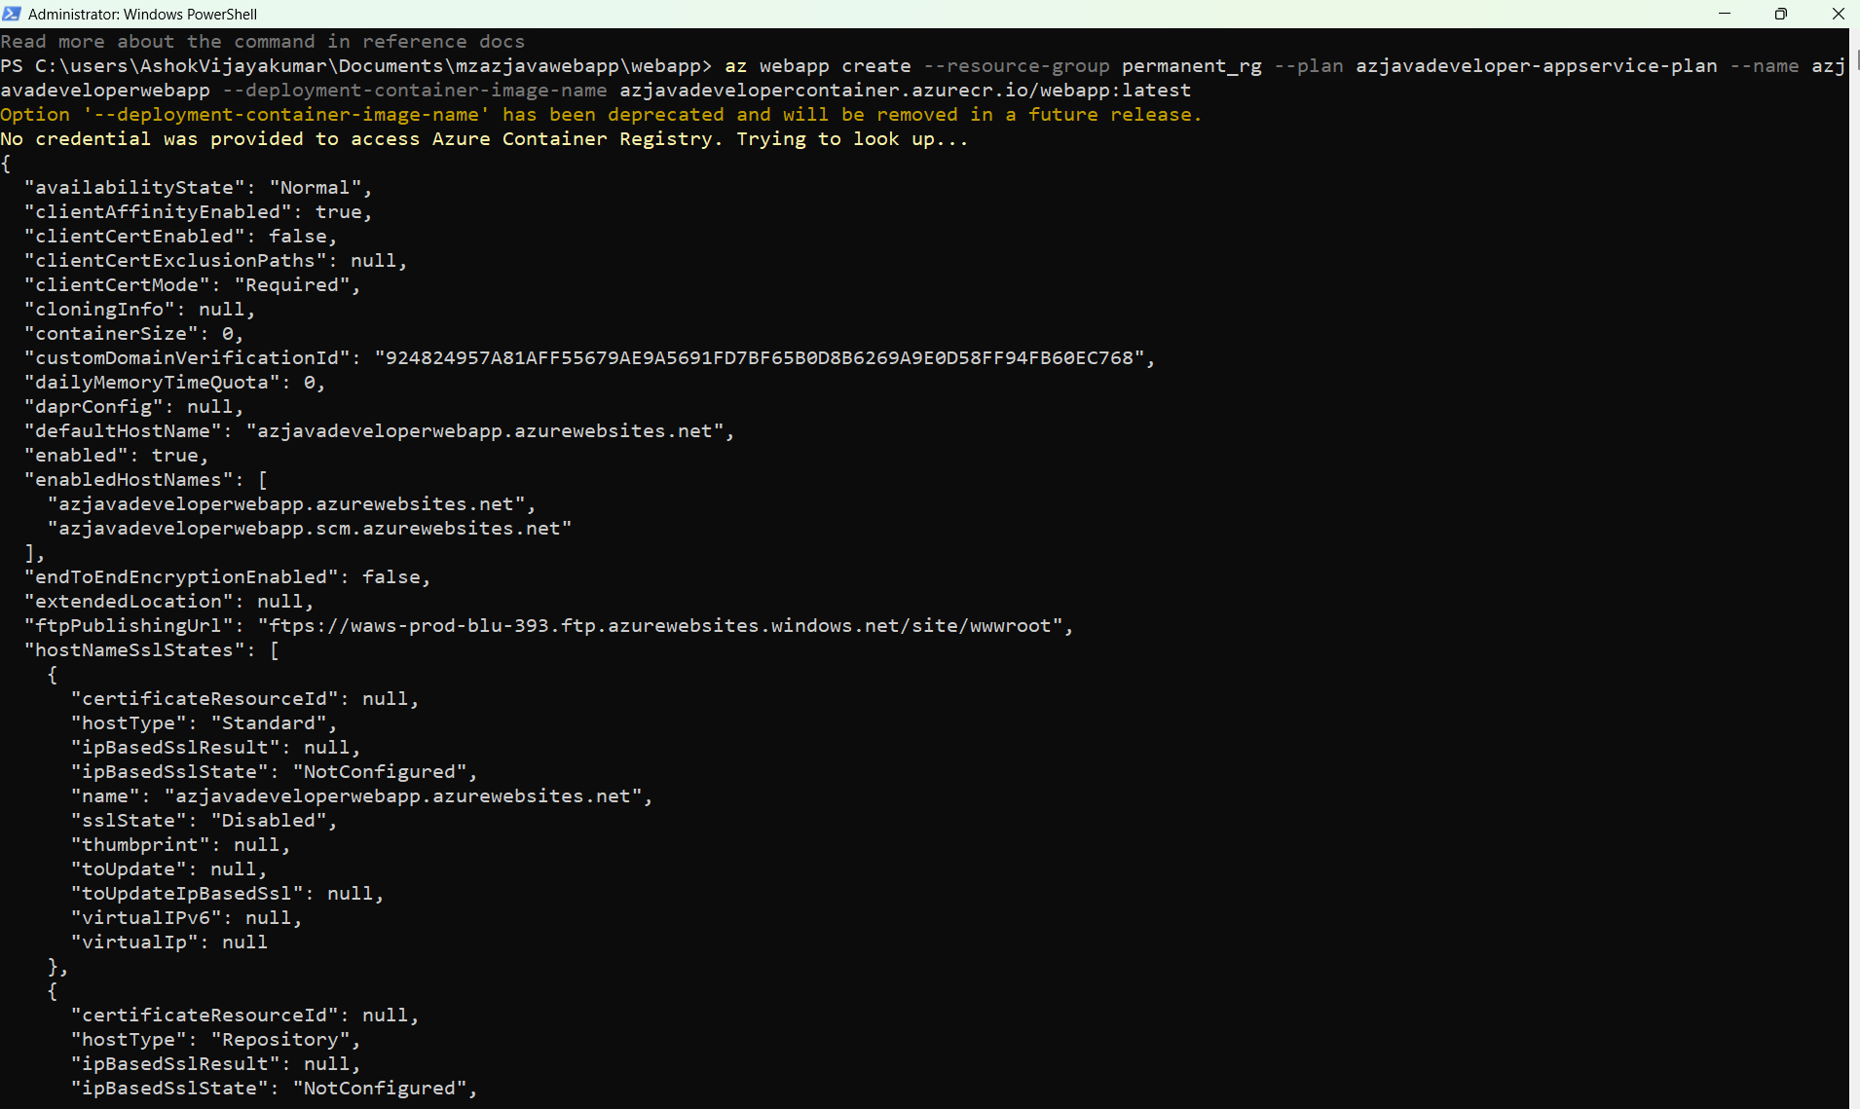

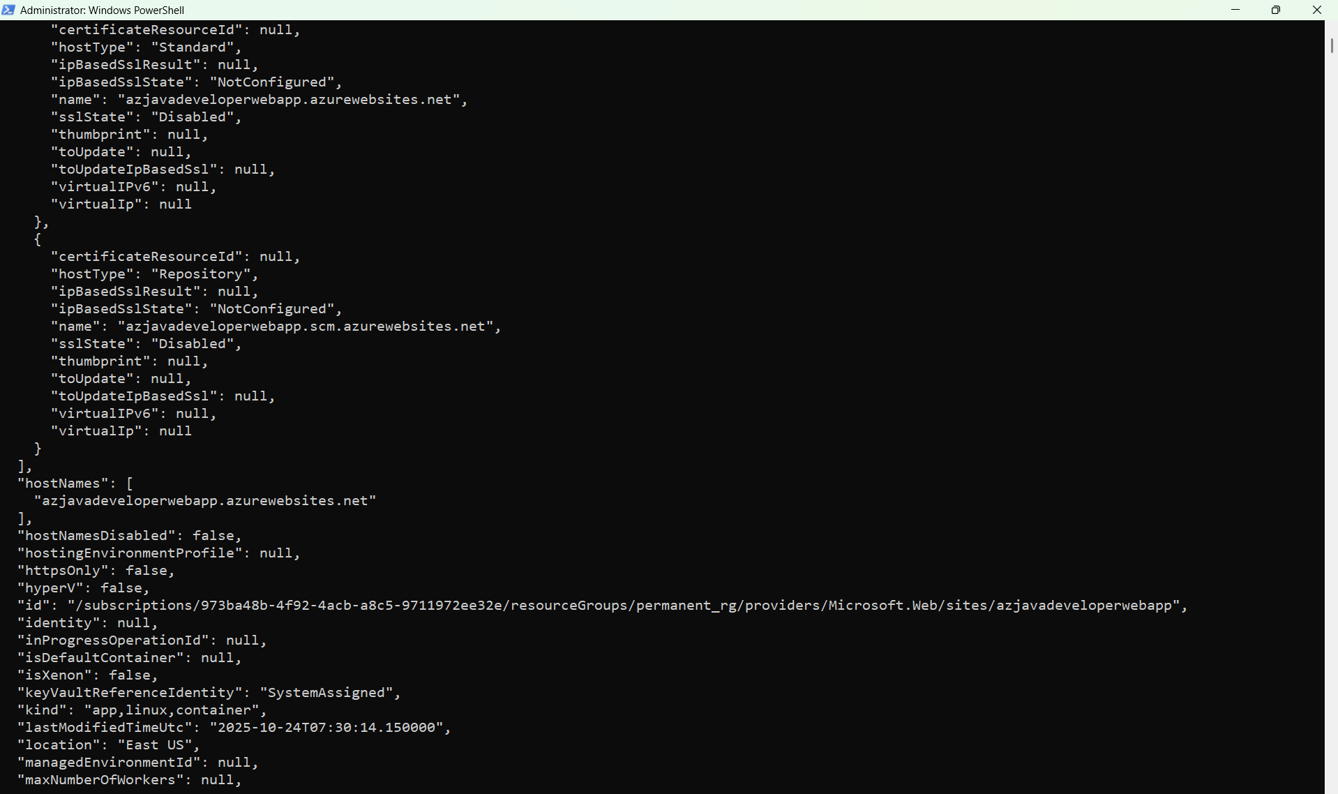
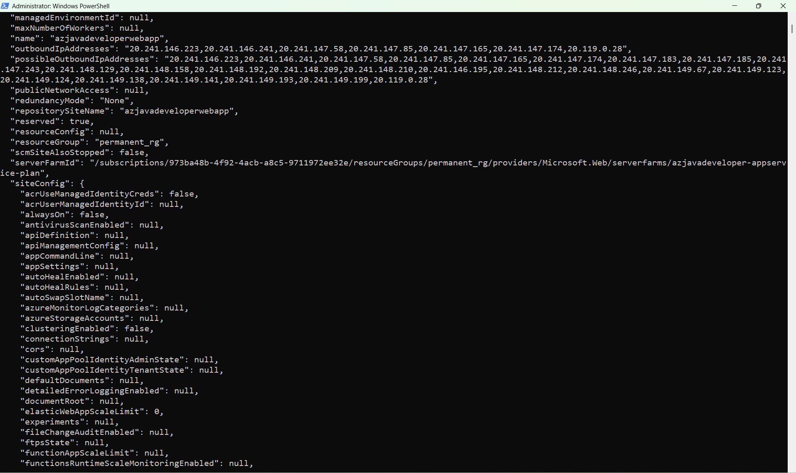
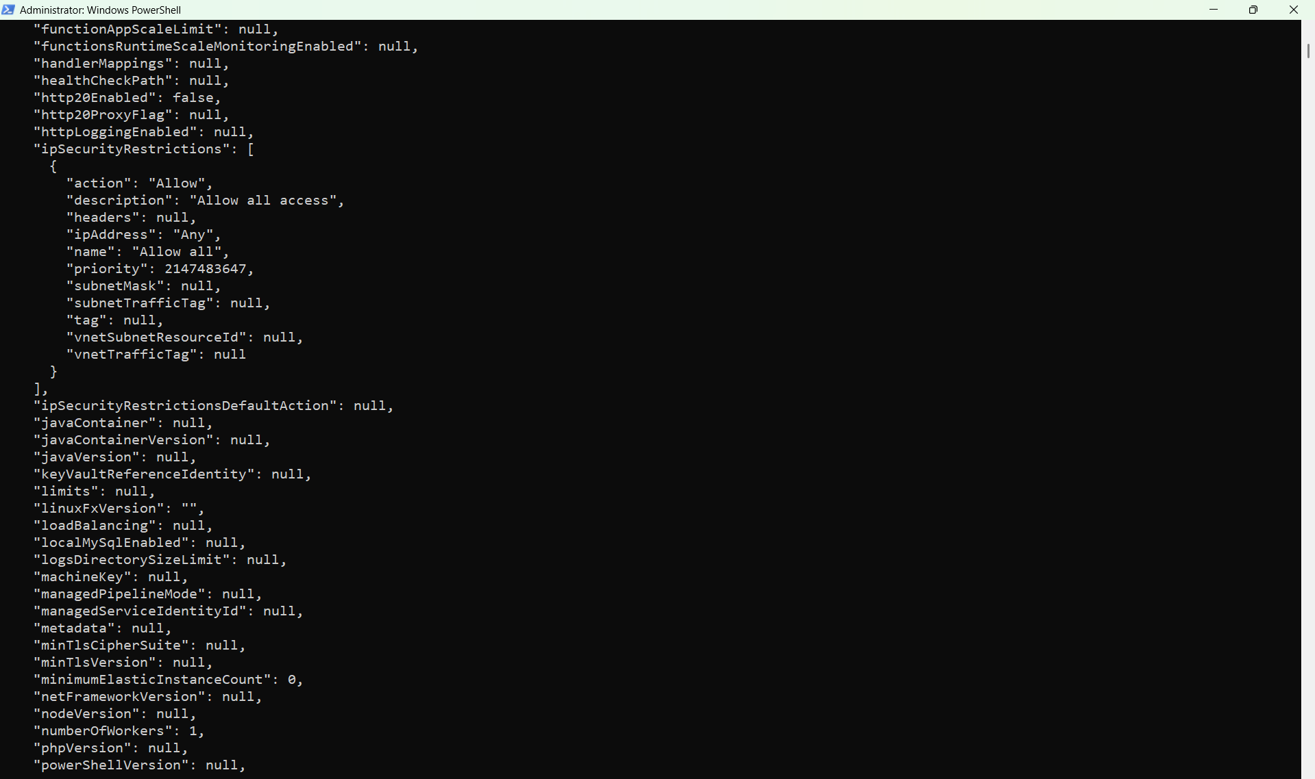
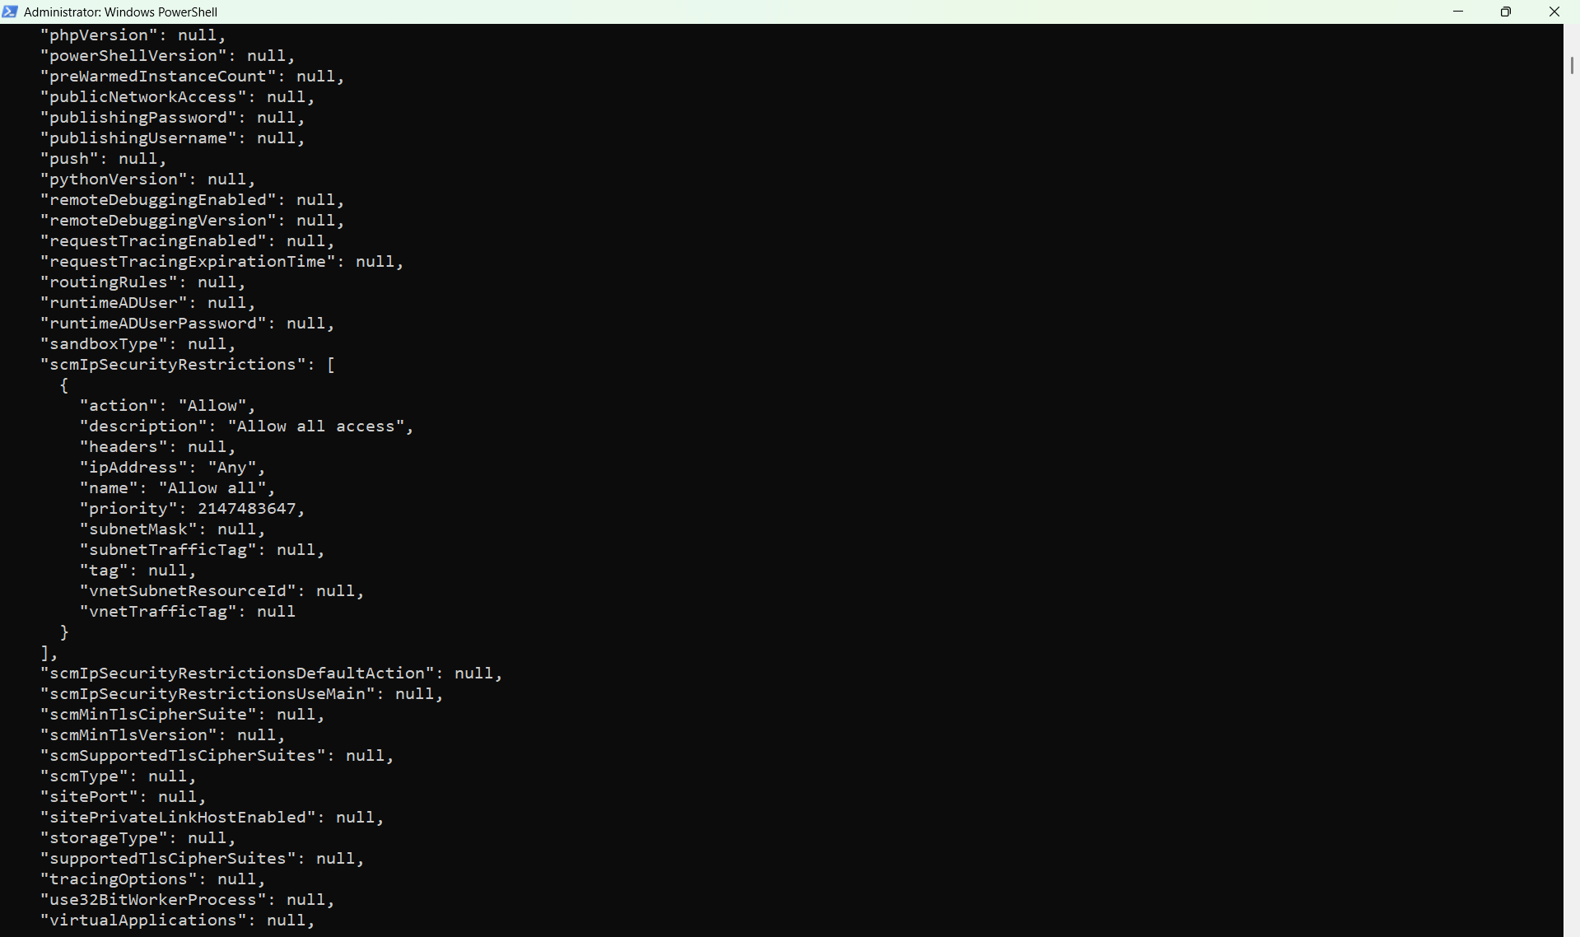
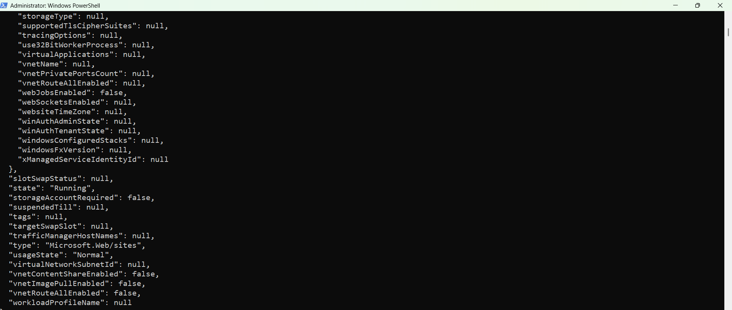
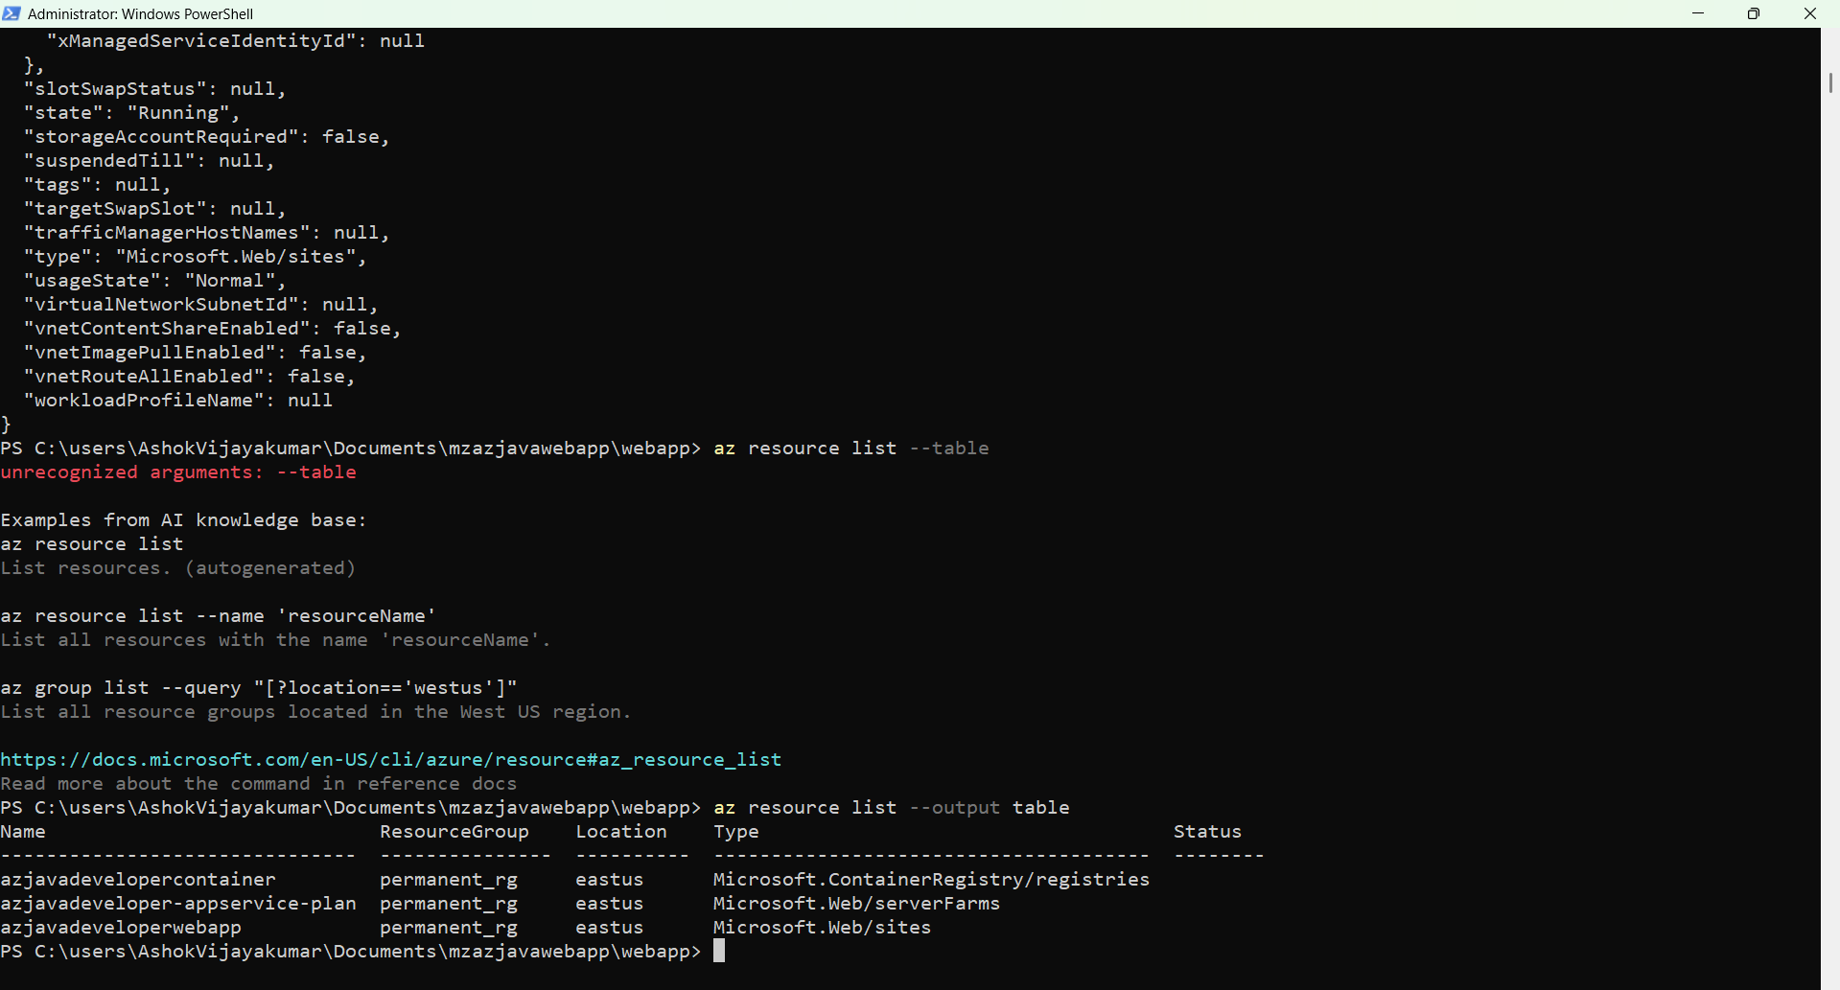

Open your web browser and visit the web app at the following address:

